**[DATA](https://www.thehindu.com/data/)**

Data | Is the Indian Army spending enough on modernising its equipment?

[https://th.thgim.com/static/theme/default/base/img/author-deafault.png**The Hindu Data Team**](https://www.thehindu.com/profile/author/The-Hindu-Data-Team-15853/)

<https://www.thehindu.com/data/data-is-the-indian-army-spending-enough-on-modernising-its-equipment/article30914534.ece>

**FEBRUARY 25, 2020 19:32 IST**

**UPDATED:**FEBRUARY 25, 2020 19:53 IST

**SHARE ARTICLE**

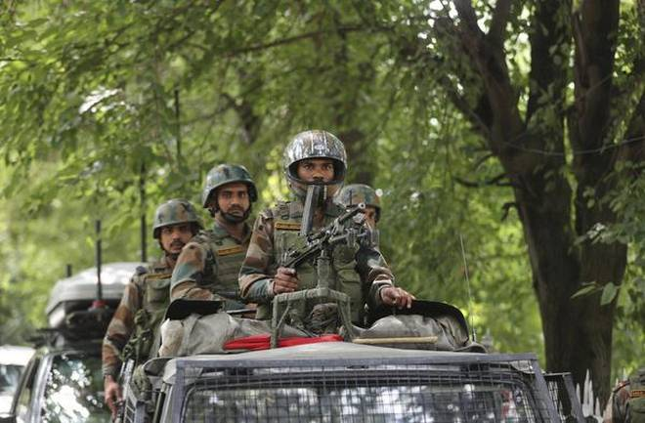

Indian army soldiers keep guard in Srinagar, Jammu and Kashmir. Picture for representational purposes.   | Photo Credit: [**AP**](https://www.thehindu.com/profile/photographers/AP/)

**Pensions and salaries together form about 76% of the Army’s budget, leaving little room for modernisation of weaponry and technology**

The Indian Army is estimated to spend more on pensions than salaries in FY21. Pensions and salaries together form about 76% of the Army’s budget. Such a high wage bill leaves little for the Army to spend on upgradation of equipments and weaponry.

**ALSO READ**

[Budget 2020 | Meagre defence hike threatens military modernisation](https://www.thehindu.com/business/budget/337-lakh-crore-allocated-for-defence-budget/article30712444.ece)

**ALSO READ**

[[&nbsp;](https://www.thehindu.com/news/national/army-critical-of-defence-budget/article23229650.ece)](https://www.thehindu.com/news/national/army-critical-of-defence-budget/article23229650.ece)

[Army critical of defence budget](https://www.thehindu.com/news/national/army-critical-of-defence-budget/article23229650.ece)

A slow-paced growth of the modernisation budget meant that only 8% of the Army’s equipments were state-of-the-art as of 2018.

**Wage bill**

The share of pensions in the defence budget increased to 28.4% in FY21 from 20.5% in FY16. The share of salaries, the biggest component of defence expenditure, has see-sawed over the years. The graph traces the share of pensions and salaries [**in the defence budget**](https://www.thehindu.com/business/budget/337-lakh-crore-allocated-for-defence-budget/article30712444.ece).

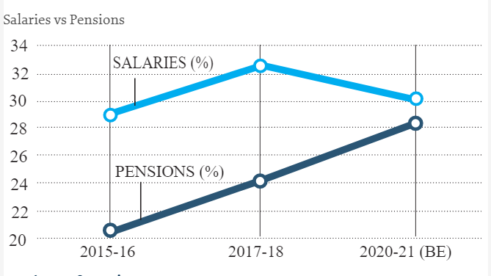

**Share of pension**

The table lists the share of various components in the FY21 budget for all the three armed forces. For instance, 38.1% of the Army’s FY21 budget was allocated for pensions. The significant wage bill meant that only about 9% was set aside for modernisation of the Army.

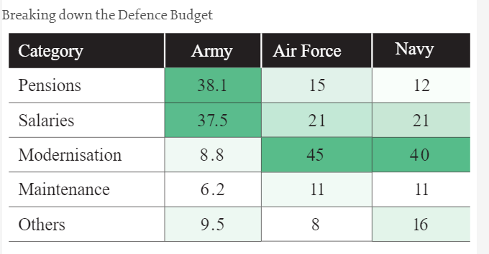

**Slow pace**

The expenditure on modernisation of the Army has grown at an annual average rate of 8% between 2010-11 and 2020-21. The graph shows the Army’s modernisation expenditure in ₹ crore.

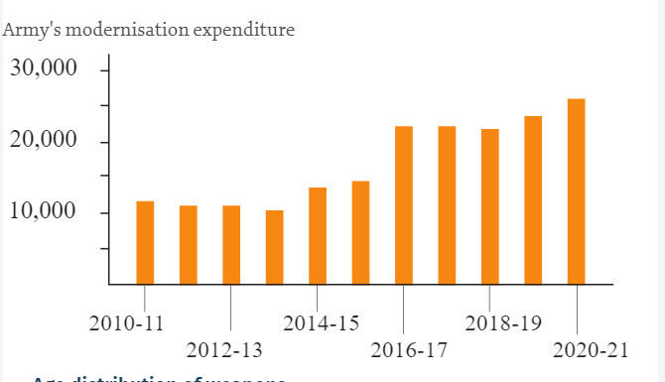

**Age distribution of weapons**

Close to 70% of the Army’s equipments and weapons are “vintage”, while the Standing Committee on Defence (2018) recommended that only 33.3% should belong to that category.

