**[DATA](https://www.thehindu.com/data/)**

Data | Which species of birds have declined the most over the last 25 years?

[https://th.thgim.com/static/theme/default/base/img/author-deafault.png**The Hindu Data Team**](https://www.thehindu.com/profile/author/The-Hindu-Data-Team-15853/)

<https://www.thehindu.com/data/data-which-species-of-birds-have-declined-the-most-over-the-last-25-years/article30859234.ece>

**FEBRUARY 19, 2020 15:01 IST**

**UPDATED:**FEBRUARY 19, 2020 15:01 IST

**SHARE ARTICLE**

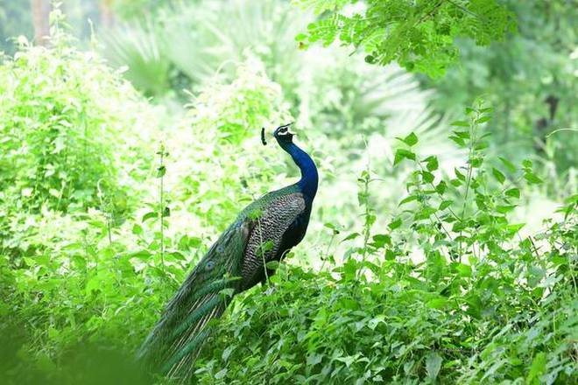

**Over half of the 261 bird species whose populations were tracked over the last 25 years declined in numbers**

Over three-fourths of the 146 bird species whose populations were tracked over the last five years declined in numbers, according to The State of India’s Birds 2020 report. Interestingly, seven of the top 10 such species were labelled as being of “least concern” (not a focus of species conservation) by the International Union for Conservation of Nature.

**Long term decrease**

The chart shows the top five species whose populations have declined the most in the last 25 years. For instance, for every 100 White-rumped Vultures spotted 25 years ago, only three could be spotted in 2020.

**Species which have declined the most in the last 25 years**

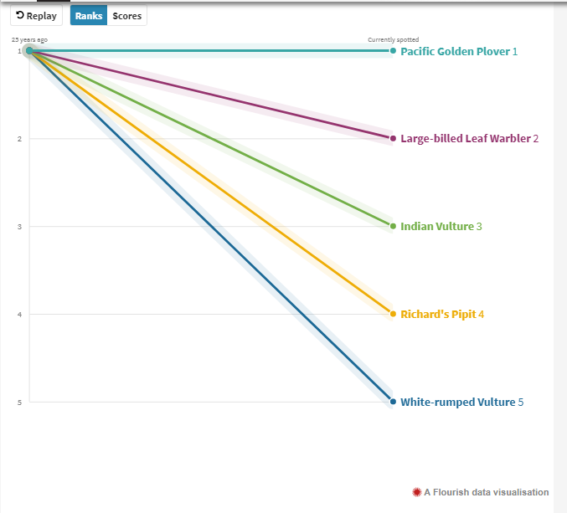

Short-term decrease

The chart shows the five species whose populations have declined the most in the last five years. For instance, for every 100 Singing Bushlarks that could be spotted five years ago, only 76 could be spotted in 2020.

**Species which have declined the most in the last five years**

[A Flourish data visualisation](https://public.flourish.studio/visualisation/1411212/?utm_source=showcase&utm_campaign=visualisation/1411212) 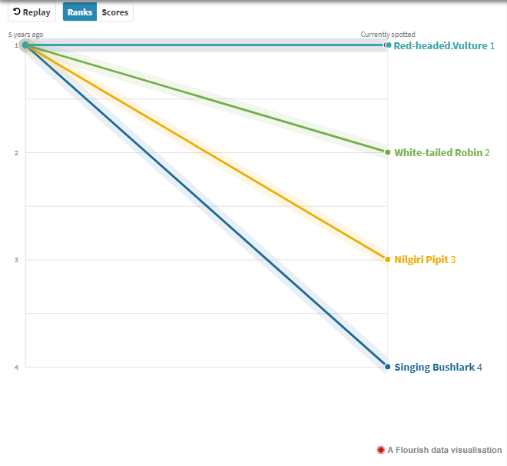

Long-term increase

The table lists the five species whose populations have increased the most in the last 25 years. For instance, for every 100 Rosy Starlings that could be spotted 25 years ago, 271 could be spotted in 2020.

**Species which have increased the most in the last 25 years**

[A Flourish data visualisation](https://public.flourish.studio/visualisation/1411185/?utm_source=showcase&utm_campaign=visualisation/1411185) 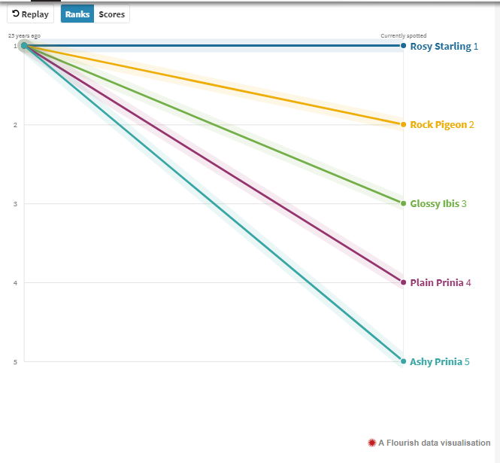

Short-term increase

The chart shows the five species that have seen the maximum increase in their populations in the last five years. For instance, for every 100 Rain Quails that could be spotted five years ago, 133 could be spotted in 2020**.**

**Species which have increased the most in the last five years**

[A Flourish data visualisation](https://public.flourish.studio/visualisation/1411238/?utm_source=showcase&utm_campaign=visualisation/1411238) 